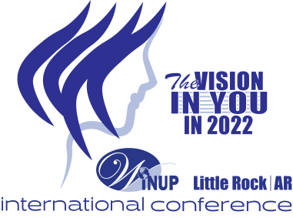

WOMEN’S INTERNATIONAL NETWORK OF UTILITY PROFESSIONALS

Empowering Women in Utilities Since 1923

Dear Potential Sponsor:

Women’s International Network of Utility Professionals (WiNUP) will be having its annual International conference September 11-14, at the Marriott Little Rock, Arkansas. The theme for this year’s conference is “The Vision in You in 2022!”
WiNUP is an international, not-for-profit 501(c)(6) association comprised of women utility professionals who work in the utility industry and allied fields. WiNUP evolved from the Electrical Women's Round Table, Inc., also known as EWRT. Founded in 1923, WiNUP has a long history of providing professional development, networking and mentorship opportunities for its members. Our membership includes professionals from a wide array of industries. Members come from such diverse industries as utilities, universities, marketing companies, law firms and everything in between. That diversity keeps meetings relevant and interesting to all who attend. Spanning across the nation with its18 chapters, the organization's current membership stands at 540 and will be celebrating our 100th Anniversary in 2023.
While our primary focus will be the utility and related industries, the 2022 conference will continue WiNUP’s traditional holistic approach to providing our members with the opportunity to hear non-utility perspectives from outside speakers who will share their leadership, career, community and professional experiences. Using this approach, we will hear not only from some of the top leaders in the utility industry but also from community leaders and many other successful professionals from all over the country.

Please review the sponsorship level information attached. Any level of sponsorship would be greatly appreciated. On behalf of the WiNUP members, and those who benefit from the efforts of this organization, we thank you for considering this request. If you have any questions, please contact us at the email addresses or telephone numbers listed below.

Sincerely,
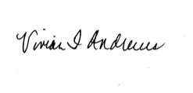
Vivian F. Andrews
WiNUP Conference 2022 Chair
Immediate Past President
AEP-Retired
Phone 318-631-8480 or 318 469-8552
vfandrews@msn.com

September 11-14, 2022

“The Vision in You in 2022”

SPONSORSHIP LEVELS

______Presenting Sponsor (Vision 20/20 Level): $20,000 or above
- Logo in Conference Program
- Full size vendor table
- Distribution of provided promotional products (ink pens, etc.)
- Six WiNUP one year membership
- A Past President’s Luncheon sponsorship to include signage of sponsorship
- Six complimentary conference registration
- Logo on Conference website

______Platinum Sponsor (Vision 20/30 Level): $15,000
- Logo in Conference Program
- Full size vendor table
- Distribution of provided promotional products (ink pens, etc.)
- Three WiNUP one year membership
- A Past President’s Luncheon sponsorship to include signage of sponsorship
- Three complimentary conference registration
- Logo on Conference website

______Gold Sponsor (Vision 20/40 Level): $10,000
- Logo in Conference Program
- Full size vendor table
- Distribution of provided promotional products (ink pens, etc.)
- Two WiNUP one year membership
- A meal sponsorship to include signage of sponsorship
- Two complimentary conference registration

______Silver Sponsor (Vision 20/50 Level): $5,000
- Logo in Conference Program
- Full size vendor table
- Distribution of provided promotional products (ink pens, etc.)
- One WiNUP one year membership
- A networking break sponsorship to include signage of sponsorship
- One complimentary conference registration

______Bronze Sponsor (Vision 20/60 Level): $2,500
- Logo in Conference Program
- Half size vendor table
- Distribution of provided promotional products (ink pens, etc.)
- One WiNUP one year membership

______Blue Sponsor (Vision 20/70 Level): $1,000
- Logo in Conference Program
- Half size vendor table
- Distribution of provided promotional products (ink pens, etc.)

______Yellow Sponsor (Vision 20/80 Level): $500
- Logo in Conference Program
- Half size vendor table

______In kind also accepted: Under $500.
- Logo in Conference Program

Sponsor Information

Company Name (proper listing): _______________________________________________
Contact Person: __________________________________ Phone: ___________________
Address: ___________________________________________________________________
City: _________________________ State: __________________ Zip: _________________

Please make check payable to WiNUP Conference 2022

Mail check to: Cindy Berry
4815 Mueller Boulevard
Austin, Tx 78723

